**NATIONAL INSTITUTE OF TECHNOLOGY**

**KURUKSHETRA**



**PRACTICAL FILE**

**SUBJECT :-** **Programming Using Python**

**BRANCH :- CS-A-01**

**ROLL NO :- 12112003**

**Submitted to:-**

**Shweta Pandey mam**

**Submitted by:-**

**Priyanshu maurya**

**Experiment-8**

1. Write a Python program to find the index of an item of a tuple.

tup=*tuple*(eval(input("Enter a tuple (items separated by , and all enclosed in ()) : ")))

item=*int*(input("ENter an item that you are searching for : "))

*# if tup.index(item)==-1:*

if item in tup:

    print(tup.index(item))

else:

    print("No found")

OUTPUT

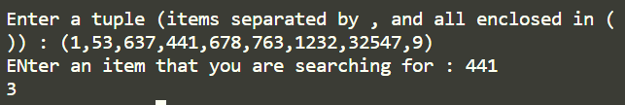

1. Write a Python program to unzip a list of tuples into individual lists.
2. Write a Python program to remove an empty tuple(s) from a list of tuples.   
   Sample data: [(), (), ('',), ('a', 'b'), ('a', 'b', 'c'), ('d')]  
   Expected output: [('',), ('a', 'b'), ('a', 'b', 'c'), 'd']

lis=[(), (), ('',), ('a', 'b'), ('a', 'b', 'c'), ('d')]

lis=[item for item in lis if item]

print(lis)

OUTPUT



1. Write a Python script to check if a given key already exists in a dictionary.

dic=*dict*(eval(input("ENter dictionary : ")))

*# print(dic)*

key=input("Enter key you are searching for : ")

if key in dic.keys():

    print("Key already exists")

OUTPUT

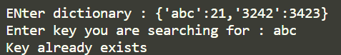

1. Write a Python script to generate and print a dictionary that contains a number (between 1 and n) in the form (x, x*x).   
   Sample Dictionary ( n = 5) :   
   Expected Output : {1: 1, 2: 4, 3: 9, 4: 16, 5: 25}

n=*int*(input("ENter N : "))

for i in range(1,n+1):

    ans[i]=i*i

print(ans)

OUTPUT



1. Write a Python program to get the maximum and minimum value in a dictionary.

dic=*dict*(eval(input("Enter dictionary : ")))

print("Maximum value in dictoinary is ",max(dic.values()))

print("Minimum value in dictoinary is ",min(dic.values()))

OUTPUT

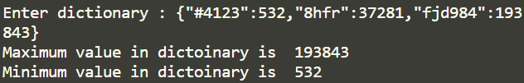

1. Write a Python program to count the values associated with key in a dictionary. Sample data: = [{'id': 1, 'success': True, 'name': 'Lary'}, {'id': 2, 'success': False, 'name': 'Rabi'}, {'id': 3, 'success': True, 'name': 'Alex'}]  
   Expected result: Count of how many dictionaries have success as True

dic=*list*(eval(input("Enter dictionary : ")))

count=0

for i in dic:

    if i['success']:

        count+=1

print(count)

OUTPUT

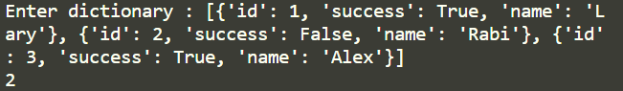

1. Write a Python program to create a dictionary from two lists without losing duplicate values.   
   Sample lists: ['Class-V', 'Class-VI', 'Class-VII', 'Class-VIII'], [1, 2, 2, 3]  
   Expected Output: defaultdict(<class 'set'>, {'Class-VII': {2}, 'Class-VI': {2}, 'Class-VIII': {3}, 'Class-V': {1}})

from collections import defaultdict

dic=defaultdict(*set*)

keys=*list*(eval(input("Enter list of keys : ")))

values=*list*(eval(input("Enter list of values : ")))

*# default dictionary with key is of type set , does not raise key error if key is not find, it will retunr an empty set*

for i,j in zip(keys,values):

    dic[i].add(j)

print(dic)

OUTPUT

